The Gully or Walcombe Slade

Now well known to a proportion of our members, this part of FOD+AG territory is
becoming more widely known, visited and appreciated by local residents as well as
people from elsewhere, many of the former group having told us that despite living
here for many years they were unaware of its existence until recently.
It is part of both an SSSI and an SAC, protected and managed for its community
of plants and animals, many of which are rare or even endangered. Around the time
when FOD+AG was formed in 2009, the Downs and Avon Gorge Management Plan
was being up-dated when, as an important and imaginative conservation measure it
was decided that the rare calcareous meadow habitat which existed in the Gully
until grazing was discontinued completely on the Downs in 1925, should be restored
This was an attempt to counter the threat to the survival of both the habitat and also
plants such as unique varieties of Whitebeam, Bristol Rock Cress, Honewort and the
Bristol Onion and animals such as the Silky Wave Moth.
In these circumstances it is unsurprising that FOD+AG should consider how it could
help and why the Gully has figured prominently, although by no means
exclusively, in our conservation work.

What follows is a compilation of recent events and developments affecting the
Gully, images from there, references to articles on the subject by local experts which
form a series commissioned for our Newsletters and current research and
speculations regarding its future conservation and development, if the two can be
successfully integrated and mutually supportive. These constituents are arranged in
a roughly logical chronology, but can of course be read in any order or selectively on
the basis of particular interests.

FOD+AG became interested in the Gully initially for 2 main reasons:

- because of the plan to fence it and to introduce a small herd (6) of Kashmiri
Goats into the enclosure thus created, as a conservation strategy for restoring
a natural calcareous meadow habitat to the site

- because we recognised the opportunity which existed to restore the Victorian
Steps as a project to celebrate Bristol’s becoming the European Green Capital
in 2015 and in so doing to improve access to this unique corner of the Downs.

These led to the inclusion, in 2010, of a butterfly monitoring transect for UKBMS in
the Gully together with the one planned for the Downs and to the opening up of the
Gully to more visitors to this little known haven for wildlife close to a busy city centre.
On our subsequent regular visits to the Gully, so many local people confessed to
being completely unaware of the existence of the Gully that we felt the need to enlist
a number of local experts to introduce the general public to the geology, geography,
archaeology, ecology and botany of the site. So this is where our chronology begins.
Below you will find references to articles by these experts and the issue numbers
and dates of the Newsletters in which they first appeared.

For Articles by Local Experts providing a background to the Gully please see the
following:

- The Gully: A Geological Introduction by Deborah Hutchinson – Issue 21 p22-25
Winter 2015/16
- The Gully: An Archaeological Introduction by Peter Insole – Issue 22 p11-13
Summer 2016
- Ecology of the Black Rock Gully by Clive Lovatt - Issue 24 p8-9
Winter 2016/17
- Plants of the Gully by Libby Houston - Issue 28 p12-17
Spring 2018
- Animals of the Gully – to be commissioned for a 2019 Issue

For Articles on FOD+AG’s involvement in the Gully please see the following:

1. Planning Document for Bristol European Green Capital (BEGC) - Issue 14 p6
Winter 2013/14
2. B-EGC 2015 ; A Downs and Avon Gorge Project - Issue 17 p12-13
Autumn 2014
3. Victorian Steps Project - Issue 18 p12-13
Winter 2014/15
4. Victorian Steps Project Update - Issue 19 p15
May 2015
5. Victorian Steps Restoration Project - Issue 20 p4-5
Summer 2015

For Articles about the Goats, who Mandy Leivers of AGDWP has nicknamed
“the hairy conservationists” please see the following:

- Goats Arrive in the Avon Gorge by Helen Hall - Issue 7 p3 –Summer 2011
- The Goat Keeper by Robert Westlake - Issue 8 p33-5 Winter 2011/12
- FOD+AG Volunteers by Martin Collins - Issue 9 p15-16 Spring 2012
- Goatally Wonderfully by Joyce Woolridge - Issue 11 p4 Autumn 2012
- Goats in the Gully by Martin Collins - Issue 15 p10 Autumn 2013
- Monitoring Goats in the Gully by Richard Bland - Issue 26 p17 Autumn 2017
- An Untimely Death by Martin Collins - Issue 26 p20-21 “ “

Recent Gully Development Ideas
A number of distinct changes have occurred in the Gully as a result of the presence
of the goats and even to the casual visitor the major ones are self-evidently the
death of many trees and the disappearance of much of the scrub. However no formal
survey has been published as yet, so we have pieced together some observations of FOD+AG members and some speculative proposals for the future of this site, its conservation, its maintenance and its use for education.

The first question that arises has to be, for non-initiates, - Where is the Gully?

The Gully Location

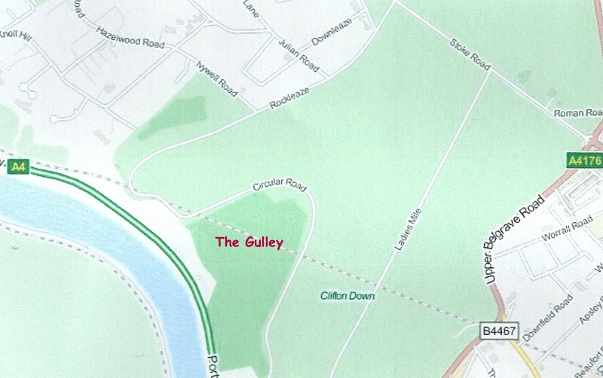
Map of Downs near Sea Walls

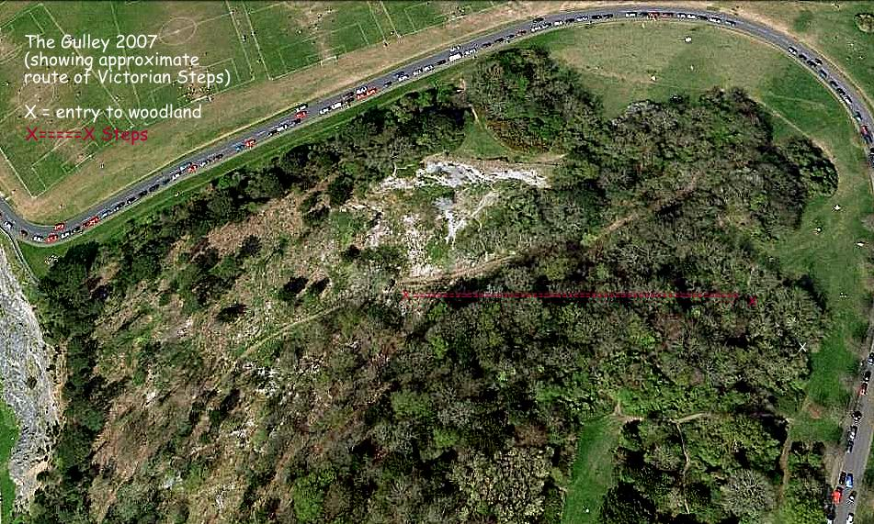
The Gully – Aerial Photograph

Some Observations in the Gully

As most of you will now be aware, the Gully is that part of “our patch” in which the small herd of feral goats (affectionately referred to by Mandy Leivers of AGDWP as the “Hairy conservationists”) are domiciled. It is a steep-sided limestone valley in the northern wall of the Avon Gorge, which since the spring of 2011 has been fenced to contain and protect the goats introduced into the Gully in June of that year.
When this happened, the careful siting of 9 kissing gates in the perimeter fence ensured that access to the public footpath leading from the Downs plateau to the banks of the Avon was maintained and might even have been enhanced. It is hoped that the newly restored Victorian Steps will further that enhancement. It should also be noted, however, that the Gully is part of the Avon Gorge SSSI. This means that visitors are accessing a highly sensitive and ecologically important location and therefore share in the responsibility for respecting its wildlife, animal and plant, whilst enjoying their contact with it.

As you would expect of a conservation project such as the introduction of feral browsers to control invasive scrub and secondary woodland encroachment into what was an area of rare limestone meadow, the installation of the goats was rigorously planned and is subject to regular monitoring of their welfare and of their impact on the environment. The use of biological control, rather than chemical (non-specific and environmentally polluting) or human/mechanical (highly labour intensive) is possible because tree saplings and woody scrub plants are the preferred provender of the feral goats. They browse rather than graze their habitat leaving the field layer of plants including the rare species which are the prime targets for conservation, untouched but also encouraged by the increased sunlight resulting from the removal of shading vegetation.
I understand that formal monitoring of the goats’ progress is being carried out and I believe one of our members, Libby Houston, is deeply involved in this. No doubt an official report on its findings will be published in due course – perhaps in June 2016 when the goats will have been in action for 5 years?
Meanwhile here are a few amateur, and mostly qualitative, observations made over the last 4 years:

- Clearance of major scrub species such as bramble and ivy is substantial.
- Saplings and coppiced shoots, mainly of ash have been kept in check.
- Many mature trees have been stripped of bark leaving them dead or dying. These include yew trees, poisonous to cattle but apparently all grist to the mill for feral goats.
- Some herb layer species have flourished, in particular violet species, which might benefit fritillary butterflies, and rock rose, which could be good news for the brown argus, but more importantly for the silky wave moth population, one of only three in the UK.
- The removal of buddleia has reduced the numbers of Vanessid butterflies such as peacocks, red admirals and small tortoiseshells within the goat enclosure.
- The gradual increase in more open grassy areas has been accompanied by increases in meadow butterfly species such as meadow browns, ringlets, marbled whites and skippers.
- On the down side, despite an apparent assurance to the contrary, the goats also seem to enjoy the bark of Whitebeams, a feature of the Avon Gorge where a unique community of varieties of this tree has evolved. Wire protection has been provided for the rarer of these.
- Goat traffic has created additional tracks up and down the steeper slopes possibly increasing areas of scree, somewhat incompatible with a meadow turf.
However, returning to the bright side, south-facing scree slopes can be an important feature of the haunts of the Chalkhill Blue butterfly

Perhaps if they read this, Libby Houston could write in to the next issue with some more detailed and accurate observations about the Gully flora, and Jen Nightingale could bring us up to date with preliminary results of the 2015 silky wave moth census which has only just been completed.
Martin Collins

The Gully Yew Wood

Many of the yew trees in the NE corner of the Gully Goat Compound are dead or dying as a result of being stripped of bark by the browsing feral goats. Despite their reputation as the most poisonous of the UKs native trees, with all but the vivid red fruiting body being toxic, it appears to be a highly popular delicacy to feral Kashmiri goats.

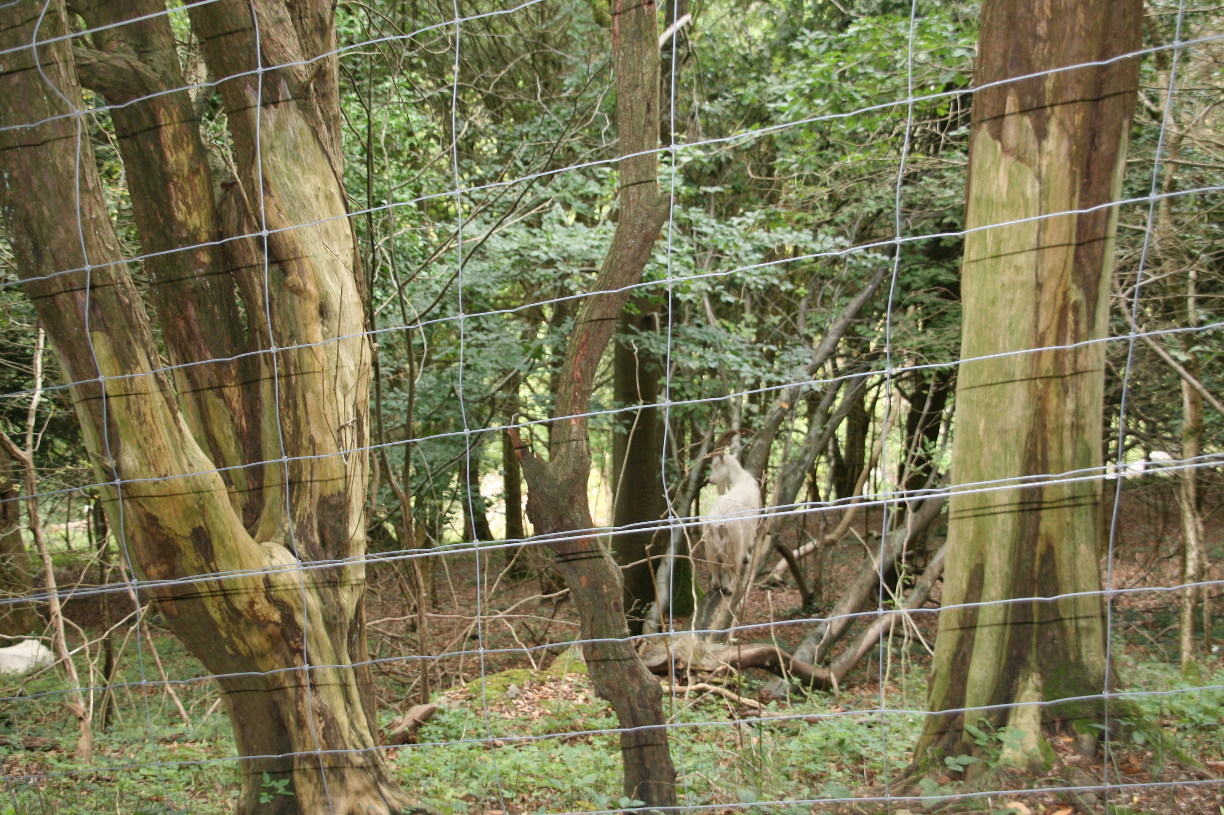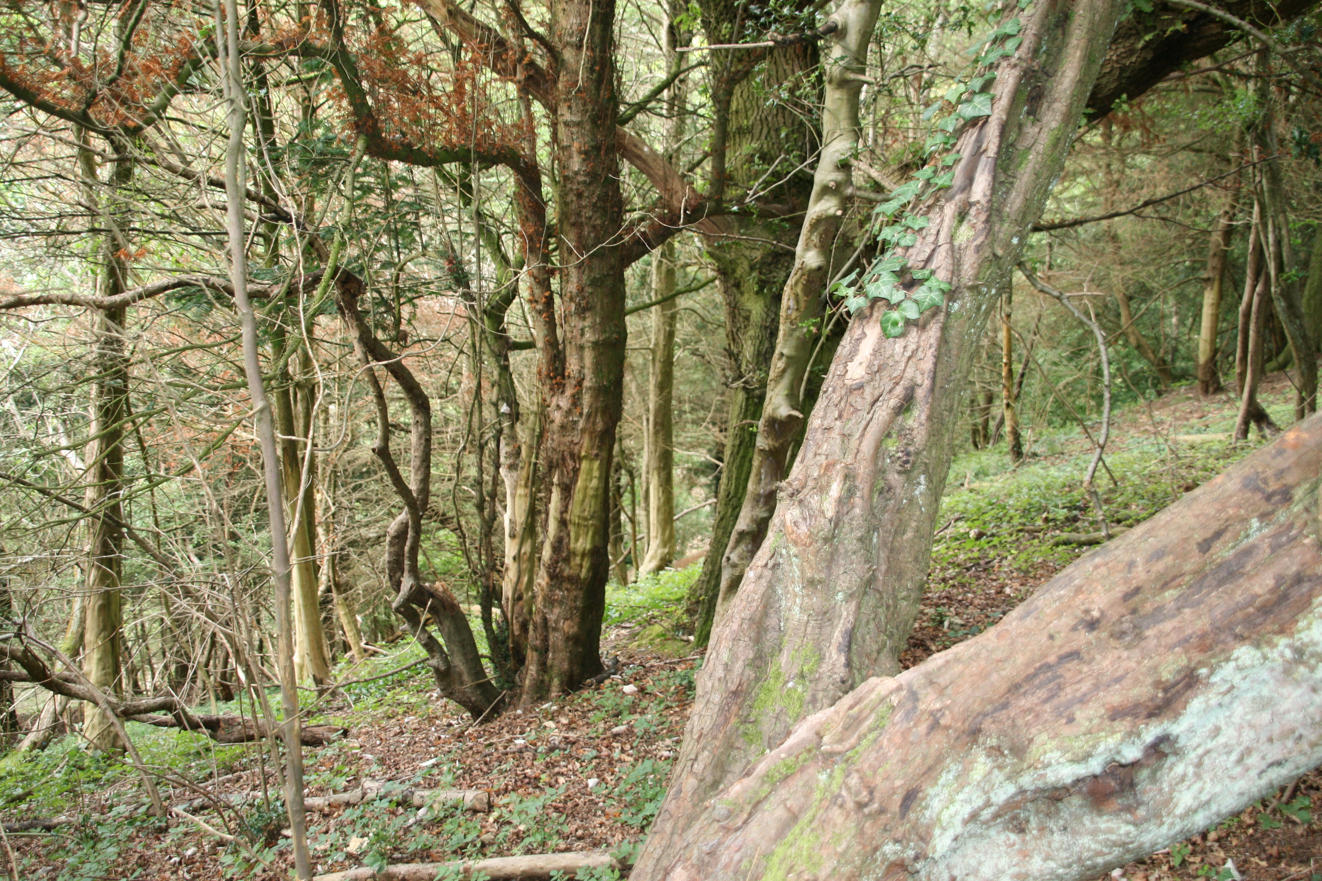
Goat damage in the Yew Wood Photographs by Graham Balfry

The death of these trees, whilst lamentable in some respects and to some people, is nevertheless seen as an acceptable outcome, even one might say a necessary one, in the restoration of a meadow habitat to the Gully as per the Avon Gorge Management Plan.
That being the case, a number of potential issues arise for the future conservation of this site. Two, in particular, are highlighted in this document as worthy of our serious consideration:

- Issue 1 : The trees in question play 3 significant roles in the stabilization and retention of soil on the Gully’s steep NE slopes by:
- intercepting all forms of precipitation, but particularly rain, with their dense canopies and so reducing water erosion.
- intercepting and dispersing air currents, including the prevailing South Westerlies, and so reducing wind erosion.
- consolidating the soil and underlying rocks by means of their extensive rooting systems.

In addition, however, the shade cast by yew trees is extremely dense and the resulting lack of direct sunlight beneath them means there is no herb/field layer plant community to bind the soil together

- Issue 2 : The net result of the death of the yew trees will be:

- the creation of an unattractive “blasted’ landscape with dead or dying trees
- the erosion of soil at a rate which could be extremely rapid and which will increase with time.
- the absence of a limestone meadow plant community due to lack of sunlight and a relatively acidic soil from the accumulated slow decay of yew leaf litter.

I have run this, and what follows past Robert Westlake as our “erstwhile insider” into the way in which the Downs Committee ‘works’ and have done a little research and tapped a contact who expressed an interest in becoming involved when I spoke to him at the recent Westbury Park Festival art and craft exhibition.
We would value a discussion of this paper, with a view to putting together a proposal for a project continuing our commitment to the future evolution of the Gully. This is clearly only a first step on a journey similar to the one which we undertook for restoring the Victorian Steps and will require consultation with a host of interested parties who we need to get on-side to have any hope of making further progress. However our recent experience of what is entailed should stand us in good stead and, if it meets with our committees approval, allow us to submit a proposal to the Downs Committee before too long.

In principle then, the solutions to the predominantly ecological problems outlined above require a carefully managed programme involving :

- the gradual felling of the dead trees
- the retention of the tree stumps and underground rooting systems
- the removal of the top layer of yew leaf litter
- the seeding of the exposed soil with selected meadow species native to the Downs and the Gully.

The outcomes of changes already occurring and those which would need ongoing management as a part of the Downs and Gorge Management Plans and the important principles which should underpin them are outlined below.

- Recognition of the primacy of maintaining the integrity of the site as an SSSI and an SAC;
- Work on site to involve minimal mechanical intrusion consistent with health and safety and completing the tasks to an appropriate standard;
- Financial support to be the subject of grant applications;
- Materials harvested to be used to help to make the project economically viable and as far as possible self-sustaining;
- Ideally some form of legacy to be derived.

In pursuance of the last two principles the ideas that have been researched relate to the nature of the harvested materials. The wood of the yew tree is, to my mind the most beautiful of the timbers produced by our native trees (and possibly by trees world-wide). We are therefore looking to celebrate it and the Gully from which it came by one or a combination of a number of the following :

- Timber from felled trees being made available to local craftsmen and craftswomen for wood-turning to create artefacts.
- An exhibition of such craftworks based entirely on wood harvested from the Gully
- Some trees to be kept in situ and carved as a small, permanent sculpture trail and representing some aspect of the history and natural history of the location.

Whilst not intended as a money-making scheme, it is conceivable that ways could be found of defraying the costs of projects relating to the Downs and Avon Gorge. These could, for example, include licenses for use of the wood, a proportion of the proceeds from sales of the artefacts being donated by the artists, sale of the timber, donations requested for visiting the sculpture trail, an entrance charge for a one-off exhibition.

Some thoughts upon which to ponder prior to the inclusion of this as an item on a future FOD+AG Committee Agenda.

A FOD+AG Project Proposal for the Gully

In 2015 FOD+AG played a seminal role in the restoration of the Victorian Steps, which now
once again have made a significant contribution to improved and increased access to the Gully.
This was our project to celebrate Bristol’s status in that year as European Green Capital.
The presence of the small feral goat herd in the Gully have, by 2018, altered the ecology of
the location in the way that was planned by the Steering Group charged with implementing
the last 10-year Downs and Avon Gorge management plan.
For a variety of reasons we believe that the time has come to respond to these changes and
the challenges that they present.These were outlined in a paper sent to the Downs Committee,
to Bristol City Council, to the Management Plan Steering Group and to Natural England nearly 2
years ago. We have since had to badger the interested parties for even an acknowledgement.
Whilst recognising, although I admit not fully understanding, reasons for their current
inaction, that complex management planning involves assigning priorities; and accepting that
there are constraints, it is clear that any progress towards meeting particular challenges is
likely to be slow. This is why we are currently carrying out research to flesh out a proposal
which addresses the changes wrought by the goats stripping bark from the trees in the Yew
Wood in the NE corner of the Gully.
Without at this stage going into too much detail, we would like you to have an idea of:
- the current situation
- the potential implications &
- how, in general terms, our proposal would be remedial and make a virtue of necessity.
The Current Situation:
- The site is part of an SSSI and an SAC
- Many of the trees (especially the Yews) are dead or dying
- It is a sloping plateau subtended by cliffs or steep slopes above the Victorian Steps;
- It is also a popular refuge for the 4 remaining feral goats

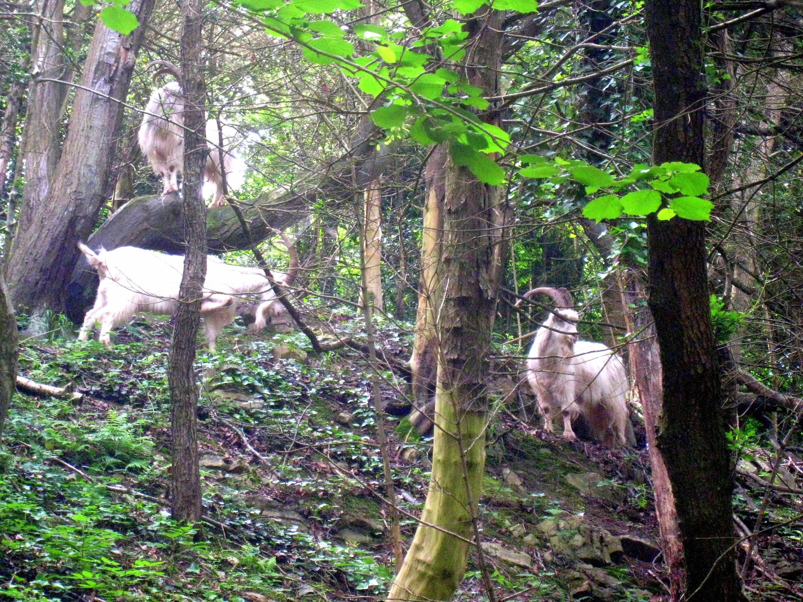

The Potential Implications:
- The dense ‘leaf’canopy once provided by the Yew trees is opening and will continue to do
so leaving the soil beneath increasingly exposed;
- This soil is covered by a thick but only slowly decaying acidic yew leaf litter;
- Exposure to wind and precipitation will result in erosion of the soil downslope into the
Gully;
- What will remain is a predominantly dead landscape with unstable soil, which will be not
only unproductive but also a potential eyesore;

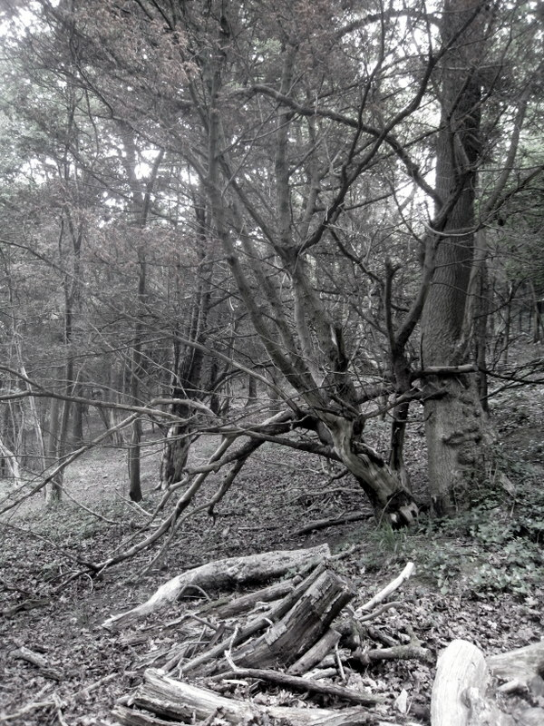

Solutions from FOD+AG Proposal
- Dead standing trees would be sculpted to create a local native wildlife trail for use by
the Avon Gorge and Downs Wildlife Project’s education officer, Mandy Leivers;
- Other suitable dead wood would be cleared and made available/sold to local wood turners;
- Unsuitable wood would be used to provide wood-pile habitats for fungi, invertebrates
and other wildlife;
- Site would be minimally landscaped a) to create the trail; b) to create natural steps
where needed for ease of access and c) to install barriers to reduce the risks of soil
erosion in vulnerable locations;
- Yew leaf-litter could be cleared to provide soil for re-seeding from Gully flora in pursuit
of the original purpose of the Project – to restore a meadow community to the location;
- Gradual development of a turf would be aided by the ongoing opening of the canopy to
light;
- The turf would eventually help to stabilize the soil as would the retention of the rooting
systems of the standing trees.

There are many permissions we will have to seek before any chance of realising our ambitions
might be given approval, but we are keen to demonstrate a detailed understanding of all
underlying issues and a seriousness of intention for when it comes to making a formal proposal
and for seeking sponsorship/funding.

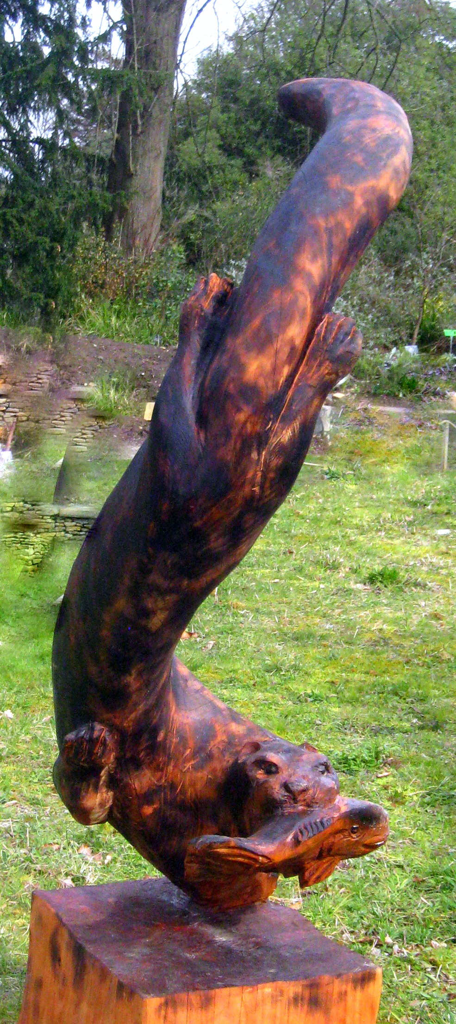
Yew-wood carving of an Otter by Denius Potter

As of now we would like to build a team of members with an interest in a project of this kind.
We are especially keen to enlist someone with experience of land surveying.

So if YOU are acquainted with the mysteries of theodolites, with map-making or with land-
scape engineering PLEASE GET IN TOUCH and let’s demonstrate that in the absence of
municipal support for the futures of our precious Green Spaces, people like us can
nevertheless move mountains!
Martin Collins June 2018

Following the publication of this article in Newsletter Issue 29 (Summer 2018), from the feedback
we received and a subsequent correspondence I have compiled the following document from
Graham Balfry which he has kindly given us permission to quote.

The Gully Sculpture Trail Proposal – Correspondence
,
Martin,
I am grateful to you for your stimulating article in Fodag newsletter and your reply to my enquiry which have given me a great deal to think about: Some opinions, thoughts and further questions.

THE NAME

Yew Wood Gully
The Gully
The Goat Gully
Black Rock Gully
Walcombe Slade

If, as seems likely, Walcombe originated from the Saxon/Early English words eow for yew, and cwm for wooded valley then it follows that yews were predominant in the valley in the past. If it were my choice, in recognition of this, I would prefer to stick with Walcombe Slade. Since 2011, and probably for a limited time, there is a goat enclosure within Walcombe Slade, even though its yew component has been reduced.

BCC’S 2012-2017 DOWNS AND AVON GORGE MANAGEMENT PLAN 2012-2017

Like many of BCC’s policy documents this 5-year plan reads very well, but whether for lack of funds or political will, like most of BCC’s policy documents it fails to carry through. It is disappointing that the goat scheme seems not to be being properly monitored. Mention in Downs Committee minutes earlier this year of a draft Management Plan will it is to be hoped facilitate better reporting of what is an ecological experiment with goats.

THE FUTURE OF THE GOAT EXPERIMENT

You identify, correctly in my opinion, the importance of “maintaining the integrity of the site as an SSSI.” Natural England publish very little detail relating to the gully. Any current concerns held about the ecological status of the gully are not adequately dealt with.
https://designatedsites.naturalengland.org.uk/SiteUnitList.aspx?SiteCode=S1003073&SiteName=&countyCode=0&responsiblePerson=&unitId=&SeaArea=&IFCAArea=

As you say, yews provide very dense cover and little will grow beneath them. I do not know whether it was intended that so many yews should be destroyed. My understanding of the purpose of introducing the goats was to open the canopy to encourage more grassland spp. It was good news that Richard Bland reported that the grassland species had greatly increased over a short time. It could be argued that the goats are now redundant, but left without further control by animal’s teeth ….. saplings and climbers would soon recreate a shady canopy.....The canopy will only remain “open” if controlled.

The goats and the fence have a limited life. Are there plans in place for when the goats are reduced to three? two? one? zero? …..

….It is clear that these goats show a marked preference for yew bark….. but I have now come to agree with your acceptance that many yews will be lost. However, if desired, a few might survive if further damage can be prevented by wrapping the trunks in wire mesh…..

Looking at the site I would not expect significant increase in soil erosion resulting from the loss of the yews. Development of ground cover plants will help to bind the soils. Some further rock exposure would not be a bad thing in terms of habitat diversity and exposure of geological features…… Leaf litter causes acidity….. but rather than interfere with the soil structure, with all its complex of insect, fungal and bacterial components, natural processes should be allowed to take their course.

Dead trees near the pathways need to be felled for public safety; otherwise they could be left to fall naturally. Fallen trunks can be left to decay where they fall. I admire the skills and work of sculptors in wood but for my taste I prefer not be distracted by such artefacts in a wild landscape; so I would not be in favour of your suggestion in this matter………

Ecological monitoring of this site should be a research project overseen by a suitable academic. On your paper: “Some observations…”, I presume this was been written 2 or 3 years ago. Did Libby Houston respond as suggested? Her expert input would be very welcome. Has the site received the attention of other academics? Might we hear from Nick Wray (whom you mention)?.......

I recognise that this subject occupies only a small part of Fodag’s many areas of interest, and that several other organizations have involvement. It will be interesting to discover what other Fodag members have to say.
Graham

Gully Yew Wood – An Update

Following my article in Newsletter 29 (Summer 2018), we have been pleased with the correspondence which it generated and hope that it will encourage others to broaden the opinions presented to the membership by this means.
A summary of questions raised and my response, together with further background for which I am grateful to our correspondents follows. For a more detailed review please see our website.

- The Downs Management Plan referred to can be found at www.bristol.gov.uk/documents/20182/32863/The-Downs_v3.pdf
- To the best of my knowledge the review of the goat project scheduled for 2015/6 has never been published, nor completed;
- The documents sent to the Downs Management Steering Group are now available on the FOD+AG website, having not been published previously awaiting consideration by the steering group;
- The steering group has not responded and indeed has met only intermittently sinc that time;

- The name Walcombe Slade derives from Saxon/Early English – eow meaning yew and cwm meaning wooded valley – bearing witness to the antiquity of the Yew Wood at this site;
- In the absence of any protection of any living yew trees which have so far survived goat-browsing, the use of some dead specimens for tree sculpture would at least preserve a tenuous link with its heritage
- Potential soil erosion with the loss of the canopy is, of course, speculative but remains a risk that should not be ignored.
- The nature of the ground cover plants to consolidate the soil would certainly not constitute a calcareous meadow community
- Some monitoring of the evolving plant community in the Gully has been carried out by the late, lamented Richard Bland as a part of his and FOD+AGs voluntary programme and also, I believe by local expert Libby Houston;
- The suggestion that ecological monitoring should be a research project overseen by an academic consortium might well grow out of the initiatives above together with an Engaged Learning Project involving FOD+AG and Bristol University Geography Department. This latter has been proposed, and is due to start in January 2019, although once again neither BCC nor Natural England has responded to repeated requests for permission/blessing for this non-intrusive soil-based investigation.
- Neither of our two major correspondents was enthusiastic about a sculpture trail, one preferring a fully wild landscape and the other being nervous and circumspect about the prospect.
- Without rehearsing my arguments again, the latter does, however, ignore both the educational potential of this development of the site and also its contribution to the heritage of the site whether ecological or human.

Since the original proposal was submitted I have met with Ben Skuse, area supervisor for the Downs, and Mandy Leivers, Education Officer for the Avon Gorge and Downs Wildlife Project, whose reservations about a Sculpture Trail in the Yew Wood will be included in an article in the next Newsletter.
As a result of all of these contributions to the debate I have formulated a new proposal which addresses as many of the concerns expressed as possible and this too wil appear in Newsletter 32 Spring 2019. By way of an introduction the net ambition of the modified proposal would be to develop a small ‘outdoor classroom’ with opportunities for the study of meadow plants, invertebrate animals and log-pile microhabitats whilst simultaneously encouraging children (and adults) to observe, examine and appreciate animal sculptures in wood, illustrating wildlife species native to this area as well as experiencing the beauty of wood as a material for creative art work.

Martin Collins - January 2019

Yew Wood Sculpture Trail – New Proposal following Site Meeting 2018

After a Meeting with Ben Skuse (Site Manager for NW Bristol)) and Mandy Leivers (Education Officer for
AGDWP) - both of whom, although not averse to the introduction of Tree/Wood Sculpture into the Gully,
had reservations about the siting of a trail in the Yew Wood – an adapted proposal was developed. The
result follows as a series of ideas which might be incorporated:

- Entry to and exit from the goat enclosure via Gate 6 (see FOD+AG goat monitoring map) to a mostly
grassed area with few remaining living trees except on the southern and western edges where the
land falls away steeply towards the bottom of the Gully.
- This area slopes towards the SW, although not too steeply, and could provide a comfortable teaching
space using already felled timber for seating supplemented by further trunks cut to make them safe
or to protect the goat fencing in some places.
- A view down to the river could be opened up by removing 3 dead trees which happen to be precisely
located to afford this view and the location could be further enhanced by the siting of a carved/
sculpted wooden bench, perhaps illustrating the life cycle of a butterfly.
- This already open grassy area contains a number (7 or 8) of dead trees suitable for sculpting and
developing into a short wildlife sculpture trail which does not encroach on the Yew Wood recognised
to be an important refuge for the remaining 4 goats.
- It would also mean that the “tidying” of the refuge area, which Ben considers unimportant and indeed
contrary to the natural embodiment of habitat transformation which the browsing by the goats was
intended to accomplish, would not be necessary and most, if not all of the dead trees within the
site would remain as skeletons.
- There could be some scope to ecologically improve the diversity of the herb/field layer by selective
seeding the area, but it is not clear a) how natural the development of a meadow community is to
be achieved nor b) whether the influence of the predominantly yew leaf litter on , for example soil
pH is acceptable in the reinstatement of a calcareous/limestone meadow community to the site.

- What is not addressed by this new proposal is the objection held by Mandy Leivers to bringing
children to the Gully/goat enclosure via G6 through the woodland strip which separates it from
Circular Road.
This is, at heart, a social issue and involves the use of the area concerned for sexual liaisons –a
situation which has never been challenged beyond some scrub clearance in the time of the last
Downs Ranger, Robert Westlake, some years ago, on whose retirement the post was abolished
as a cost-cutting exercise.
Personally I do not see why this initiative should not be continued, if only in the small area
needed for access. To be blunt, it is a question as to which takes precedence – the “rights” of
an adult group to indulge in outdoor sexual activity, whether hetero- or homo-sexual, in an area
very close to a public highway or the “opportunity* for a child-based group to be able to safely
access a valuable educational site or merely to play outdoor games?
I know where my sympathies lie despite there being some who would accuse me of being discri-
minatory.
- The net result of the modified proposal would therefore be a small outdoor classroom with
opportunities for the study of meadow plants, invertebrate animals and log-pile microhabitats and,
simultaneously, to observe, examine and appreciate animal sculptures illustrating local wildlife
species, many nocturnal and therefore generally inaccessible to most visitors, in a natural environment
as well as the beauty of wood as a material for creative art work.

Martin Collins August 2018

A Very Recent and Unexpected Research Development

In the autumn of 2018 FOD+AG were made aware of an initiative involving the
University of Bristol Geography Department entitled “Engaged Learning” in which
students in the 2nd Year of their degree course are charged with completing a
short project proposed by local community organisations, such as FOD+AG, and
endorsed by the University. The purpose of the scheme is to give students experience
of planning, conducting and reporting on an investigation that is assessed as a part
of their further education but simultaneously engages with real challenges identified
by environmental groups and thereby makes a valuable contribution to their local
work.
At a time when stewardship of the natural environment is threatened by budgetary
cuts by both National and Local Government agencies, FOD+AG sees this initiative as
a heaven-sent opportunity to both further our explorations of ways of caring for local
habitats and wildlife and also to contribute to the education of those on whom the
future health and welfare of the planet might depend.

We, therefore proposed two investigations which are important to all Downs Users
And were delighted that a group of 5 students selected one of our projects to study
From the outline document below:


Engaged Learning Project Proposals 2019

University of Bristol Geography Department & Friends of the Downs and Avon Gorge

Soil-based Investigations for FOD+AG

1.The Gully or Walcombe Slade

2. Areas of the Downs used for Car Parking

Introductions and Contexts
Students might find helpful an App called “My Soil”

Context: 1. In historic times Clifton and Durdham Downs have been grazed and therefore prevented from developing natural scrub and woodland ecosystems. Soils were originally and traditionally thin and, overlying limestone, alkaline.
Local topography made quarrying relatively straightforward and therefore commonplace
In more recent times significant infill of worked quarries has taken place and grazing was finally completely discontinued almost 100 years ago.
As a result the Gully (or Walcombe Slade to give it its Saxon name) has undergone successional changes from a calcareous meadow habitat through scrub to woodland.

The part of the Avon Gorge in which it lies is both an SSSI and an SAC. As a part of its management plan, a small herd (6) of feral Kashmiri goats was introduced in 2011 as an experiment in biological control/conservation in an attempt to re-establish a meadow habitat. In doing so it was hoped to help to conserve the biodiversity of the site and the survival of rare and threatened flora and fauna.

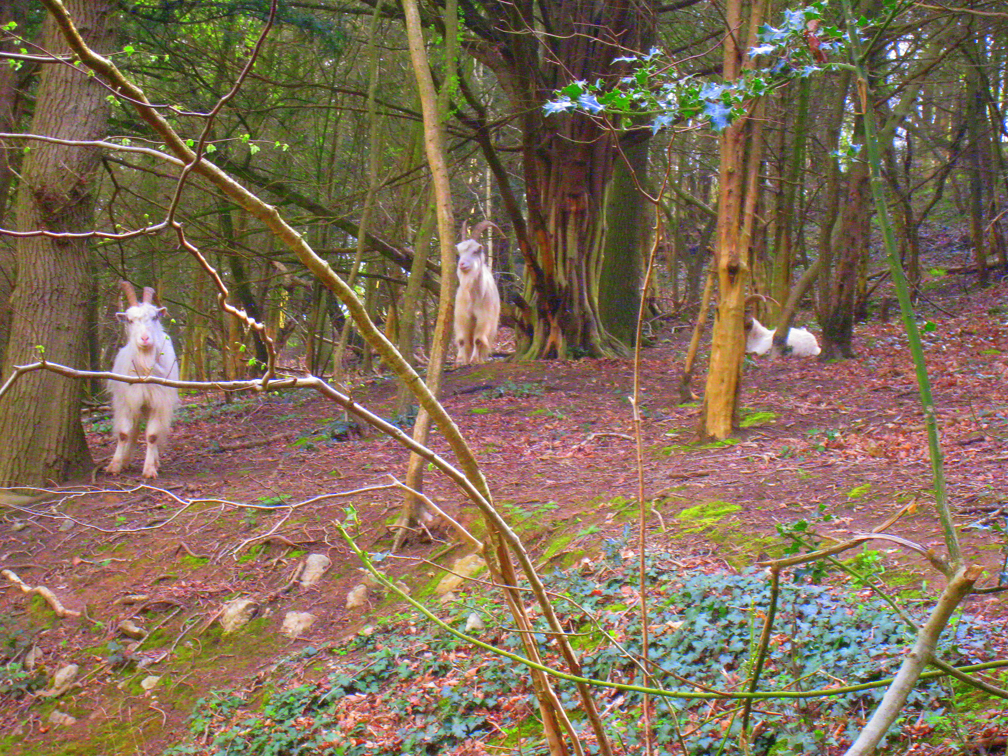
Goats in their Behavioural Refuge in the Yew Wood

In broad terms this project will investigate aspects of soil structure, stability and chemistry.

Context: 2. In 1861 Parliament passed the Bristol Downs Act, promoted by its joint owners – Bristol City Council and the Society of Merchant Venturers. The Act protected the Downs and adjacent Avon Gorge as an unenclosed Green Space in perpetuity. Since that date the area has been managed and maintained with 2 principle aims:

- Conservation of biodiversity of habitat and wildlife native to the region
*
- Promotion of outdoor leisure activities for Bristolians and their visitors.

The balance between these two, though not without its inevitable, if only occasional, conflicts of ˙interest has been achieved remarkably well. However, changing times bring fresh challenges and one of FOD+AGs major concerns is to ensure that the spirit of the Downs Act is not compromised.
Pressure from national government, transposed to local government – both of which appear to have a limited knowledge and understanding of the importance of Green Spaces to the health, well-being and happiness of people, especially city-dwellers – have resulted in significant cuts in financial support. This in turn has translated into a need for Green Spaces to generate their own incomes to fund survival.

The main impact, as regards the soil, is due to vehicle parking, temporary installations and localized intense footfall in certain parts of the Downs, all of which already occur and are likely to increase in the future.

In broad terms this project will also investigate aspects of soil structure and chemistry but with particular reference to compaction and perhaps pollution.

Suggested Properties of Soil for Investigation/Data Collection

- % particulate composition Soil Depth
% Water Leaf Litter Depth
% Humus Leaf Litter Composition
% soil atmosphere Slope
Dissolved Minerals Aspect
pH Drainage/Percolation Rates
Stability

- As above plus
Pollutants Compaction

Suggested Locations for Investigation/sampling

- Cliff=top meadow overlooking Gully Quarry and A4 / Quarry meadow
Yew Wood / woodland fringe outside goat enclosure
Scree slope below viewpoint / Circular Road meadow area outside enclosure
Central path area / path through quarry outside goat enclosure
Fenced goat exclusion area / suitable control area

- Zoo overflow car park / adjacent non-parking area (off Ladies Mile)
Main site for e.g. Fairground etc / adjacent triangular plot (Westbury Road)
Main area for Circus / area adjacent to Dumps (Top of Blackboy Hill)
Official Barbecue/Picnic Site (Ladies Mile) / adjacent open meadow area
Desire Line path/track for runners / adjacent wildflower meadow (Circular Road)

Martin Collins & Jeff Hurran (for FOD+AG) - January 2019

