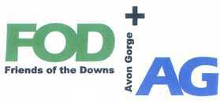
Friends of the Downs and Avon Gorge
Annual General Meeting
November 2018

Agenda
1 Welcome & Introduction: R Westlake
2 Apologies J Solomons
3 Minutes of the AGM {2017}: R Westlake
4 Matters arising from minutes “ “
5 Finance Report: B Bell
6 Chairs address: R Westlake
7 Change to the constitution: B Bell
8 Election of the committee R Westlake
Mystery Item
Break for Refreshments
Guest speakers.
1. Susan Sanctuary: Parks Foundation
2 Paul Wood: New Hotwell in the Avon Gorge {1730} History & Survival

